Ready to Burn Application Form  Certified by HETAS Ltd | 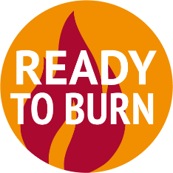

HETAS Ltd is the DEFRA appointed Certification Body to administer the Ready to Burn Scheme for manufactured solid fuels (MSF) as recognised in Part 4 of The Air Quality (Domestic Solid Fuels Standards) (England) Regulations 2020.
Section 1. Business Contact Details
Details of main contact.
Please provide us with the name of the person responsible for Ready to Burn registration. This is who we will address all correspondence to. If you are a sole trader this will be you.
* Indicates required field
* Business / Trading Name:
* Main Contact:
* Correspondence Address:
 |  |  | * Postcode:
* Main Contact email:
Public email
Business Website (if applicable):
* Telephone: | LANDLINE: |  | * Distribution:  (delete as appropriate) | Local / National
 | MOBILE:
* Business Type  (as appropriate): | Sole Trader ☐ Partnership ☐ Limited Company ☐ Local Authority ☐ Other ☐

Section 2. Fuel Sales
Please tick the relevant boxes
* PRODUCT SOLD | Bagged MSF | ☐ |  | * HOW DO YOU SELL? | Direct to end user | ☐
 | Loose MSF | ☐ |  |  | To retail outlet | ☐

Do you sell under additional Brand Names? Please list below:
Brand Names | Product Sold As
N.B. If you are not applying for a rebranded fuel (i.e. it is a new fuel not based on an already certified fuel) please enter the same fuel name in both columns.

Section 3. Ready to Burn Scheme Fee Structure
Prices effective from 1st Dec 2020 - all prices listed are exclusive of VAT
APPLICATION AND ANNUAL FEE
One off, new fuel application fee | £950 per fuel (+ vat)
New fuel brand or rebranded fuel (based on already certified fuel) | £475 per fuel (+ vat)
Annual re-certification fee per certified fuel | £475 per fuel (+ vat)

- Please note for rebranded fuel the branding company will require a declaration from the fuel manufacturer that they permit the use of the fuel to be sold under the rebrand name.

- Please note that during a three year certification cycle an audit of the production site for each certified fuel will be carried out at least once at a current cost of up to £750 plus any expenses.

Section 4. Business Procedures Declaration
This confirms you have these operational procedures in place.
* I can provide evidence of our full production quality control processes including product specifications  (applies to manufacturers only, not the bagging of rebranded fuels) | ☐
* I can confirm that the rebranded fuel has not changed from the original sourced fuel and when bagged has not been blended with any other fuels. (applies to rebranded fuels only) | ☐
* I have a system in place to deal with customer complaints | ☐
It is a recommendation to have Public and Product Liability Insurance | ☐

Section 5. Declaration If submitting this form online please type your full name in both fields.
HETAS will handle personal data given to it by accredited businesses and applicants in accordance with its Data Protection policy and the General Data Protection Regulation (GDPR).
I understand that the information I have given on this form and in support of my application will be recorded and retained by HETAS, in accordance with GDPR. It may be used for the following purposes: to process my application and manage my registration in accordance with the Rules and Conditions of Registration; to publish my contact details as a HETAS Ready to Burn Accredited Supplier.
* | ☐ | I agree to HETAS or another nominated auditor visiting all plant and depots to be included in the scheme by prior arrangement and will answer any questions and provide documentation as requested by HETAS. All information and documentation received will be treated as confidential. Charges are separate and will be due at the time of audit. I agree to have certified fuels tested regularly and at no greater intervals than every 3 years. There may be a need for additional tests in the event of complaints or non-compliance.
* | ☐ | I have read and agree to the Terms and Conditions for the scheme and apply for certification.

(Name of Main Contact)

Signed: Date:

SEND THIS FORM TO:
HETAS, Severn House Unit 5 Newtown Trading Estate Green Lane Tewkesbury GL20 8HD
or email to smokecontrol@hetas.co.uk
Contact us on 01684 278170 for further information
Notes:
- Site audit: This will be at the registered main site. This could be in the format of a physical visit or virtual if feasible. Additional sites or depots, see ⁽⁸⁾, may be audited separately. Following a successful new application and site audit, future audits will be on a risk-based approach e.g. more frequent audits may be deemed necessary rising from complaints or poor results from previous audits. During a site inspection your auditor will facilitate taking a representative fuel sample(s) for testing.
- Fuel test: Verification of fuel smoke emission and sulphur content is a requirement of the certification scheme. Each unique fuel product will be allocated its own certification number. HETAS will endeavour to ensure that testing of all certified products during a tri-annual certification cycle is carried out. All testing must be carried out by an accredited laboratory. Please contact HETAS for further details. N.B. Certified brands will depend upon retesting of their source certified fuels.
- Additional fees may be added to cover travelling expenses.
- Smoke emission and sulphur content, must be carried out by an accredited laboratory who can test to the requirements in BS 3841 and BS 1016 – 106.5:1996/ISO 157:1996 as referred to in the legislation.
- You will need to provide evidence that the MSF fuel is manufactured under a monitored quality control system.
- Additional depots: Site audits will be determined on the total amount of facilities registered together with a risk-based approach as explained in ⁽¹⁾ above. (Contact HETAS for details). Registration of additional depots, warehouse, bagging facilities etc. may incur additional charges as part of the three yearly monitoring cycle (See ⁽²⁾ above).

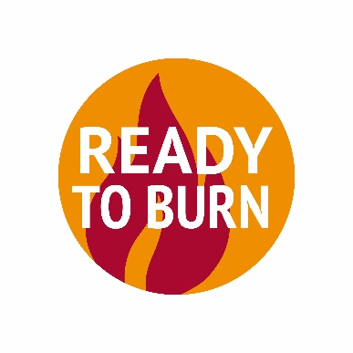
HETAS - Severn House,
Unit 5 Newtown Trading Estate, Green Lane,
Tewkesbury GL20 8HD
www.hetas.co.uk registrations@hetas.co.uk 01684 278170

